Nexora AI assistant connection
Document 23 of the Nexora learning guides
Source snapshot 13 October 2026 at 17:12 UTC
Understand the NexOrchestr AI page, its configured iframe and CRM context endpoint.

Recognise the screen and its scope
Open /assistant. CRM routes use port 3017; member routes use 3018; public website routes can use 3019. Brackets name a route parameter, not text to paste into a browser. Choose a real record or site id from the application.
This guide covers Signed-in assistant page; Configured external application URL; Allowed URL schemes; Iframe sandbox and referrer policy; CRM context boundary; Unavailable state.
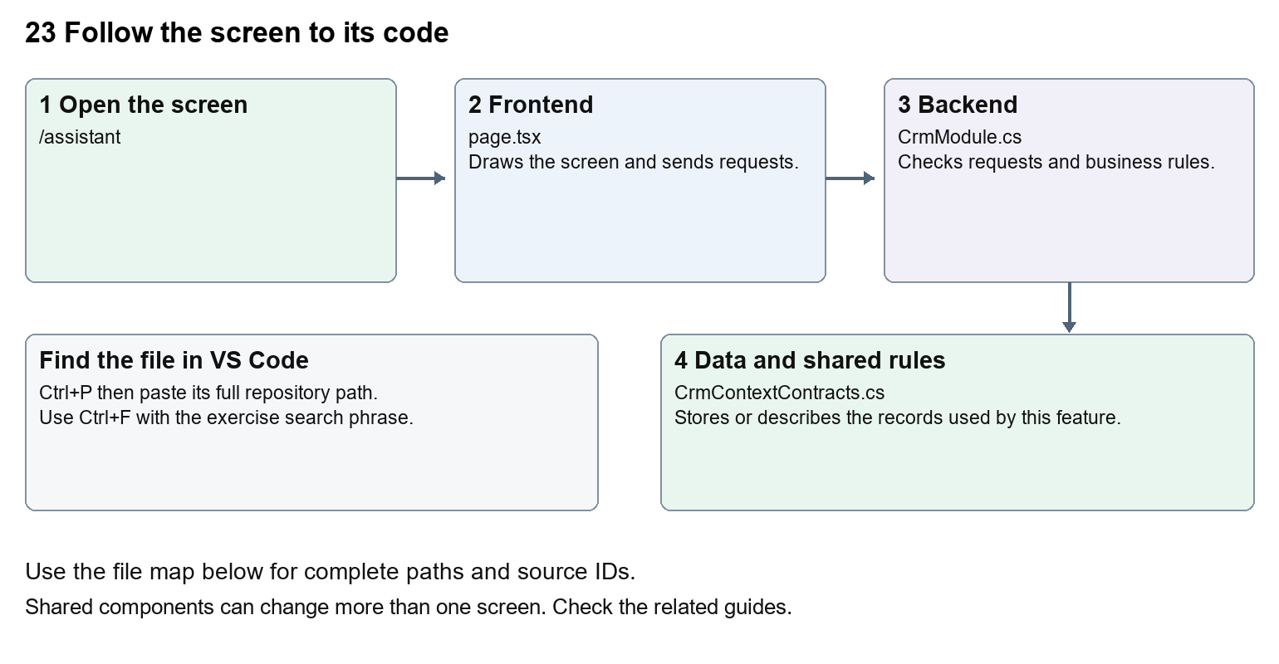
The diagram shows the file roles. The full paths below are what you paste into Ctrl+P.

Find the files in VS Code
Role | File and source ID | What it does
Screen | S0013 page.tsx | Main UI or route for this topic
Server | S0249 CrmModule.cs | Endpoints or server rules
Data | S0201 CrmContextContracts.cs | Data shape or persistence structure

Screen S0013
apps/web/src/app/(platform)/assistant/page.tsx
Server S0249
backend/src/Modules/Nexora.Modules.Crm/CrmModule.cs
Data S0201
backend/src/BuildingBlocks/Nexora.BuildingBlocks/Security/CrmContextContracts.cs
The complete HTML manual opens these source IDs inside its Source library. The Word manual shows short labelled extracts so you can learn the flow before reading large files. Each individual Markdown guide includes its complete primary files after the walkthrough.

Follow the request and the records
1. The route checks the staff session.
2. It reads NEXORCHESTR_APP_URL on the server.
3. A valid allowed URL becomes an iframe source.
4. Without valid configuration the page shows an unavailable message.
5. CRM context is exposed through an authorised endpoint, rather than unrestricted database access.

Read the code with an explanation
The repository page is a connection shell. The AI application itself is not implemented by this iframe file. URL validation rejects embedded credentials and restricts schemes. Its sandbox specifies browser capabilities. The CRM context endpoint is a separate API boundary; embedding a page does not automatically authorise it to access Nexora records.
Source reference S0013 apps/web/src/app/(platform)/assistant/page.tsx
Selected opening lines with their original numbers. The complete file is in the HTML source library.
0001 import { EntityHeading } from "@/components/ui/entity-heading";
0002 import { requireSession } from "@/lib/auth/session";
0004 export default async function AssistantPage() {
0005 await requireSession();
0006 const configuredUrl = process.env.NEXORCHESTR_APP_URL;
0007 let appUrl: string | null = null;

The import lines lead to shared components and helpers. Start at the exported component or route function; follow the request helper to the server rather than assuming the whole feature lives in this file.
Source reference S0249 backend/src/Modules/Nexora.Modules.Crm/CrmModule.cs
Extract from source line 47. A fragment from a long line is shown without the rest of that line.
0047 var api = endpoints.MapGroup("/api/v1/crm").WithTags("CRM").RequireAuthorization("crm.read");

On the server, look for MapGet to load records, MapPost to create or perform an action, MapPut or MapPatch to change data, and RequireAuthorization for permissions. Some shared methods register endpoints indirectly. Find SaveChangesAsync to see the database write. A request method alone does not tell you every side effect.
Source reference S0201 backend/src/BuildingBlocks/Nexora.BuildingBlocks/Security/CrmContextContracts.cs
Selected opening lines with their original numbers. The complete file is in the HTML source library.
0001 namespace Nexora.BuildingBlocks.Security;
0002 public sealed record CrmContextItem(Guid Id, string Label, string Status, DateTime AtUtc, string Url);
0003 public sealed record CrmContextSection(string Title, int Total, IReadOnlyList<CrmContextItem> Items);
0004 public interface ICrmContextProvider
0005 {
0006 string[] Permissions { get; }

Follow model fields to their request names and database mapping. An id points to a particular record. A tenant id limits the organisation. A version or concurrency stamp protects newer edits. Some model files describe contracts rather than tables; check the owning DbContext before assuming storage.

Make or trace your first change
1. Press Ctrl+P and open apps/web/src/app/(platform)/assistant/page.tsx.
2. Press Ctrl+F and search for The AI assistant is not connected yet. Contact your administrator to enable it.. In this snapshot it appears at line 33.
3. Replace only the unavailable-state sentence. Inspect /assistant without adding an external URL. This wording change should not enable any provider.
4. Replace only The AI assistant is not connected yet. Contact your administrator to enable it. with The AI assistant is awaiting connection. Ask your administrator to configure it. in that intended location. Keep quotes, tags, JSON keys and routes intact.
5. Save with Ctrl+S. Inspect Problems and the local screen. Review the diff and restore the original text when you finish practising.
Extract from source line 33. A fragment from a long line is shown without the rest of that line.
0033 The AI assistant is not connected yet. Contact your administrator to enable it.

These exercises have not been applied to the application. Their search phrases are verified against the captured source. Line numbers can move; the phrase and file path are your main navigation aids.

Check a change and diagnose problems
Confirm the original screen still loads, the changed words appear in the intended place, and another screen using the same component still behaves correctly. If an action fails, inspect the browser Network response, the relevant helper and server validation message. Use the common error table at the beginning of the manual. Reload on a version conflict instead of removing the version check.
A syntax error after a text edit usually means a quote, brace or closing tag changed. Compare your diff with the original. An unchanged browser result can mean the wrong port, a saved published configuration overriding a default, or a running API that has not reloaded.

Understand the current limits
A complete AI service, model configuration and provider behaviour cannot be inferred from this route. The configured external URL and its service availability need separate verification.

Continue learning
Related guides 03 Nexora workspace navigation and theme, 05 Nexora CRM contacts, 20 Nexora administration and access, 22 Nexora workflow designer and runtime.

